HMIS: BED INVENTORY AND FUNDING SETTINGS
Section I:
To arrive at the screen to adjust these settings:
- Click on Admin
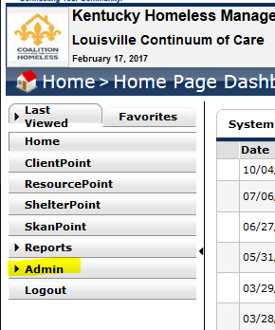
- Click on Provider Admin:
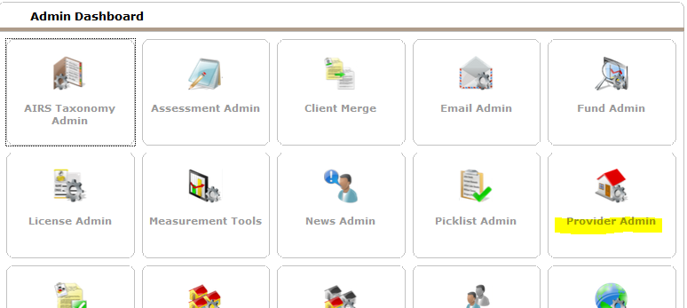
- Search for your project and click on the pencil icon to edit:
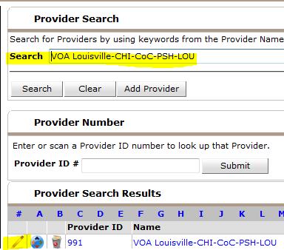
- On the next screen, under the “Profile” Tab, click on the “Standards Information” Tab: 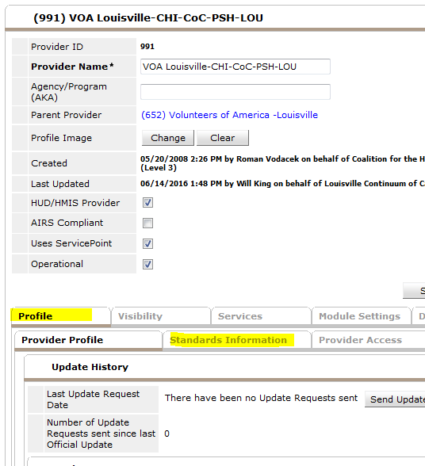
- This screen contains the fields you want to edit:
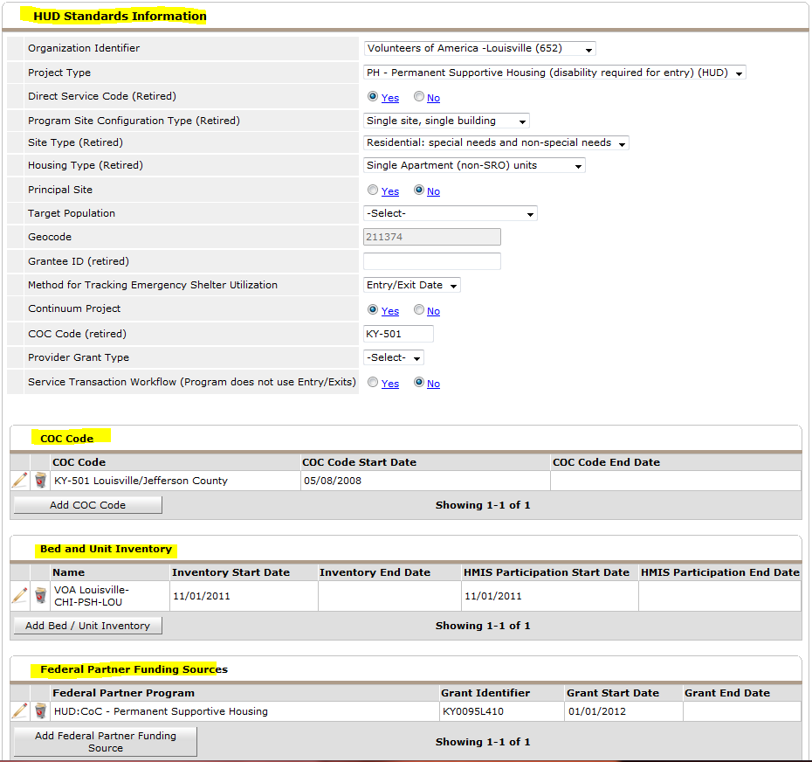

Section II
HUD Standards Information and CoC Codes: Editing this Information
- Once on this screen it is a good idea to make sure your setting under the “HUD Standards Information” is correct. This information directly affects how reports are pulled, so you want to make sure things are correct. There are some “retired” questions but because we are hoping to generate our Housing Inventory Chart from HMIS, we need to define these fields (if applicable).
- CoC Code – If your project is a COC project, then this code needs to be defined. Most projects have this set. But if something is missing or in error I would like you to update it.

Section III
Bed and Unit Inventory
- Click on the pencil icon to edit existing entry
- OR…Click the “Add Bed/Unit Inventory” to log a new entry
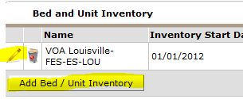
- Complete Bed/Unit Inventory Form:
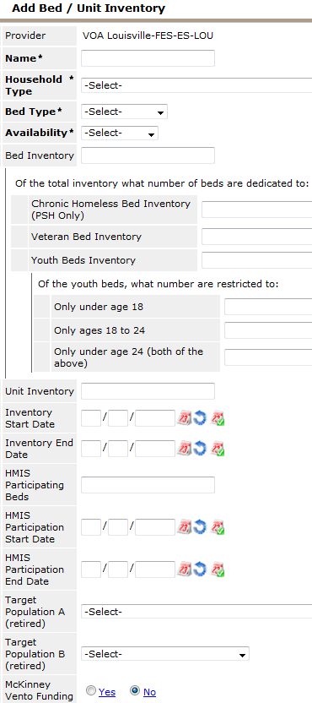
- If your project shelters/houses a combination of households, individuals and/or households with children only, you must break these out individually and create separate Bed/Unit Inventories for each.
- Household Types = Households with Children, Households without Children and Households with ONLY Children
- Bed Type = Facility-Based, Voucher, Other
- Availability = Seasonal, Year-Round and Overflow
- As defined by your grant, be sure to breakout Chronic Homeless Bed Inventory (PSH Only), Veteran Bed Inventory and Youth Bed Inventory:
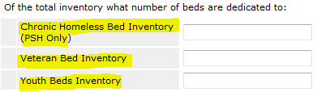
- If you have beds that are specific to youth, be sure to specify age ranges:
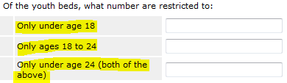
- Specify Target Population A (retired):
- Specify Target Population B (Retired) only if it pertains to: DV, Vets or HIV.
- Answer Yes/No to McKinney Vento Funding.
- Save your Entry

Section IV
Federal Partner Funding Sources
- Click on “Add Federal Partner Funding Source:
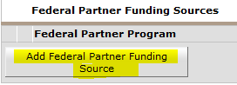
- Answer these questions:
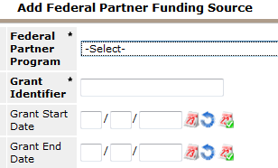
- Federal Partner Program is a list of all relevant funding sources (this is an example of some choices):
- Grant Identifier: This is the alpha/numeric grant identifier for your grant. An example would be: KY0142L41011401
- Specify the Grant Start Date and End Date. The End Date can be entered in at a different time if necessary.
- Save your entry

