SkanPoint Tutorial
SkanPoint is a tool that is specifically designed to add services in bulk to a group/list of clients. Don’t think of it as something you use a scanner with. It is a tool designed to expedite the creation of services for clients. It will not create Entry/Exits for clients. So, for example, if each month you document that a service or services are applied to clients in your project, this tool would save you from looking up each client’s record individually. For instance, you could specify that at the end of the month (say, November 30th) all 20 clients in your project received Case Care Management, Bus Tickets, and an educational service. This tool would do this quickly.
Once the services have been applied, you can verify by going into the individual client record (the Service Transaction Tab/View Service History) or by running the “Service Transaction” Provider Report (this is not an ART report).
Here are the steps:
Section I. - Logging Services
- Sign in, EDA into your project and click on the “SkanPoint” module:
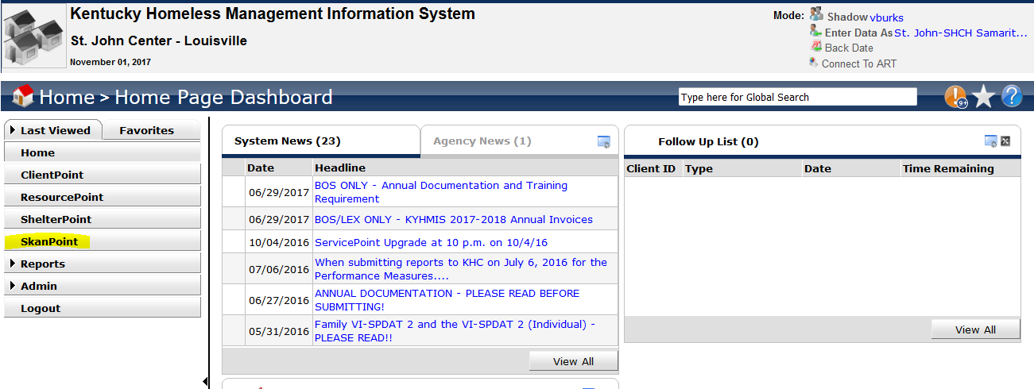
- Click on “Multiple Services”, IGNORE “Number of Service”, select your “Service Type”, and set “Need Status” to “Closed”. If you want to add more services, click on the “Add Another” button at the bottom right. Then click on “Start Skan”. If you wish to use a “Client List”, then click on “Choose Clients from Client List” (more on how to create a client list below). Edit your dates as needed.
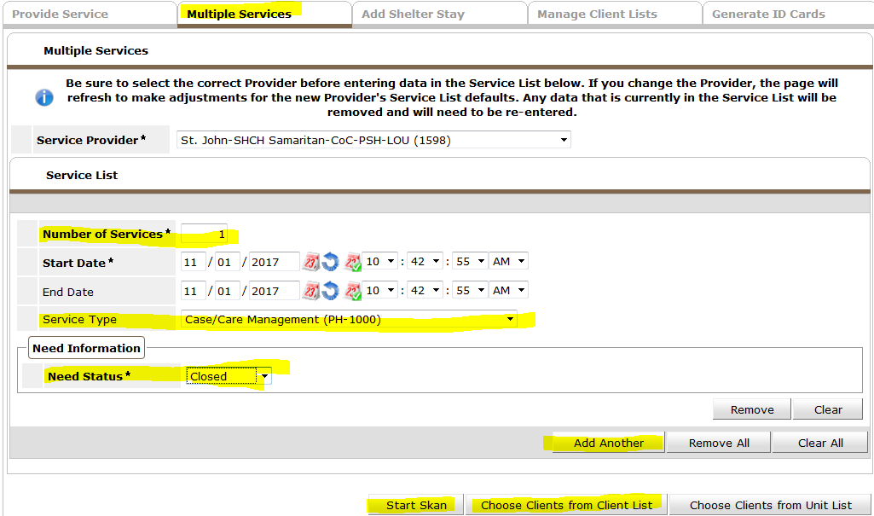
NOTE: If your project ALSO captures “Outcome of Need” and “If Need is Not Met, Reason”, then set these fields up as well.
Example:
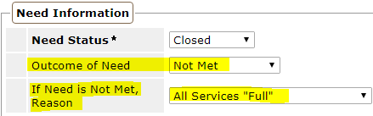
- Search for clients as needed or type in the HMIS # and click on “Skan Bar Code”. As you do this, you will be stamping the client record with the service (or services) that you specified on the screen before. Note, there is no “save” button. As soon as you hit “Skan Bar Code” the service is recorded. When finished, “Exit” or click on “New Session” if you want to apply a different list of services to clients. NOTE, it is possible for me to include an assessment on this page. So if you wanted to see DOB, Race, Residence Prior to Entry, DV, etc…you can. I think I can also display “Incidents” here as well.
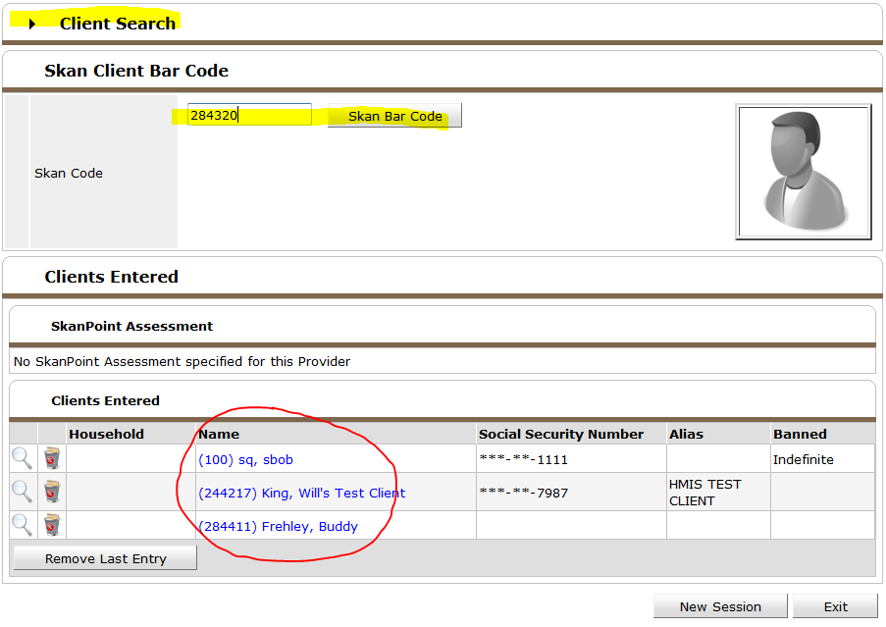
Section II. - Creating your own list of Clients within SkanPoint.
- This is easy. Once in the SkanPoint Module, click on the “Manage Client Lists” Tab at the top. You will see lists that you currently have access to. Click on “Create New Client List” at the bottom left:
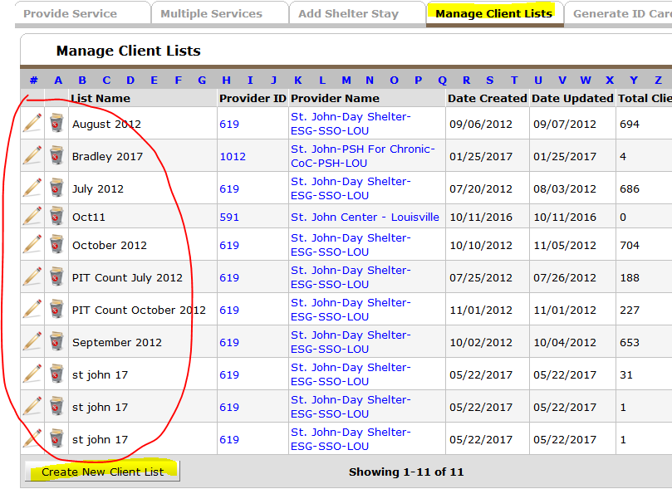
- Name your new list and save:
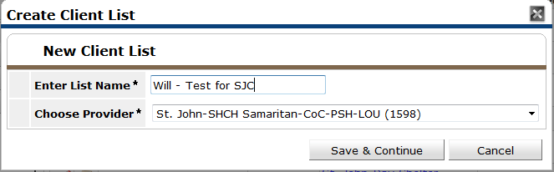
- Type in the HMIS # for any clients you wish to add to the list. Or search for HMIS Clients if you do not know their HMIS #. Your list will build as you add clients. If you need to remove a client from the list, click on the red/white delete icon. Exit when finished. You can come back to this list to edit/cleanup anytime you like.
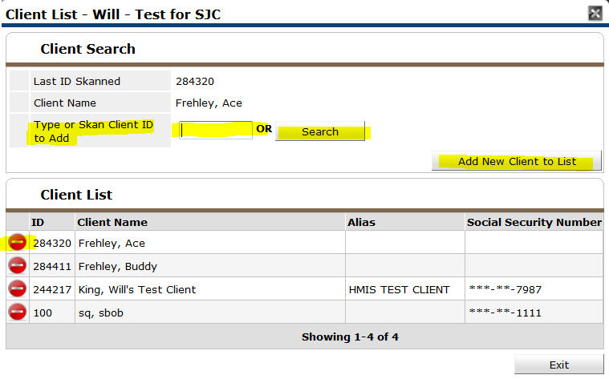
- Your new list should be visible in the “Manage Client Lists” window:
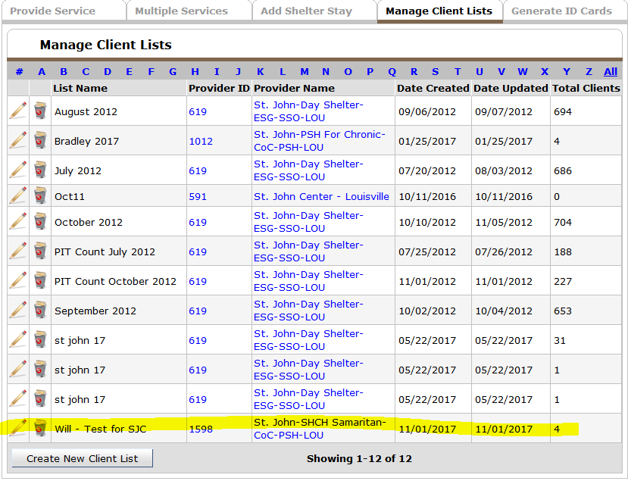
- Edit/delete as needed.
- Remember, to use your new list, simply click on the “Choose Clients from Client List” button when wanting to apply a service (or services) to a group of clients from the “Multiple Services” tab:
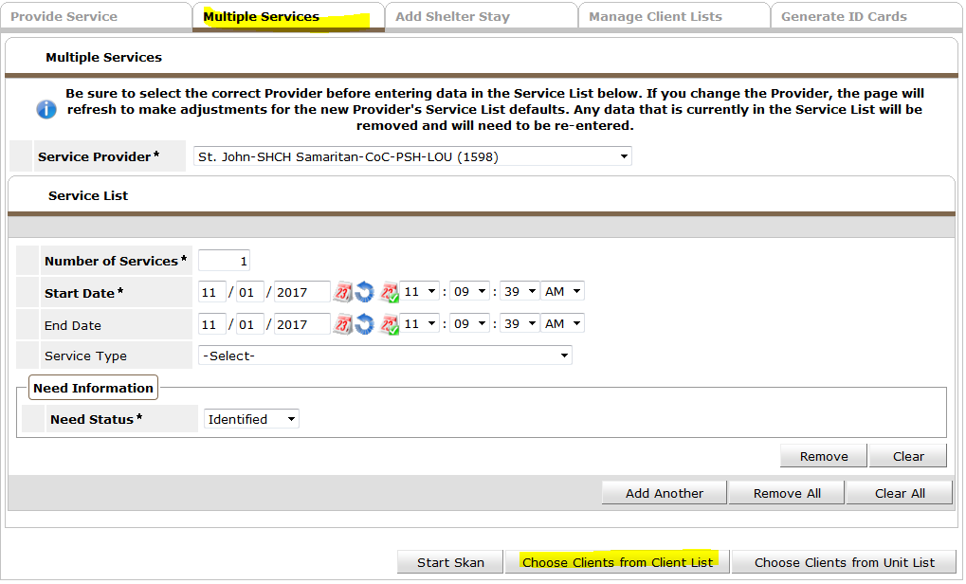
- Choose your list and click on the green/white plus icon:
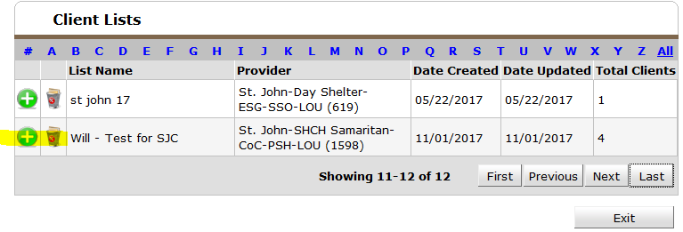
- Select your clients. Note the “Check ALL Clients” and “Clear ALL Clients” buttons. To apply your services, click on “Enter Service for Clients”:
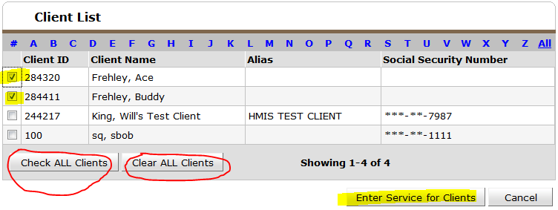
- Services will be applied:
